Steps to Build a 3D Model

Start in Object mode

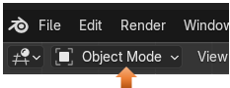

Select the cube and delete it. Then go to Front Orthographic Mode

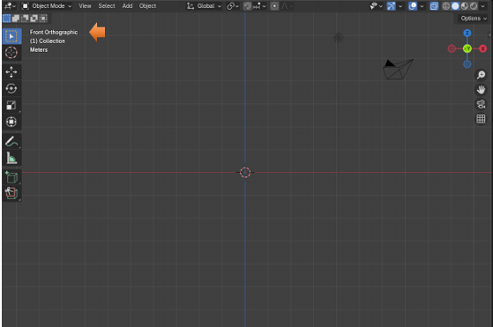

# Add the Reference Image

If you just drag and drop your image, you will notice that it disappears if you rotate the image. In order to see the reference image from any angle, it must be added as a reference image.

## Add-Image- Reference

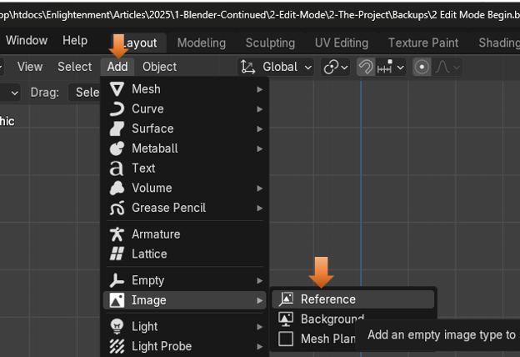

See now you can rotate the image, and still see it while working with it.

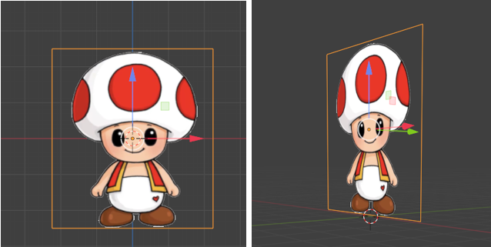

# Center the Guy in the Viewport

You also want to center the guy in the viewport, by moving him with the move tool so that the cursor is directly in the bottom, center of his feet.

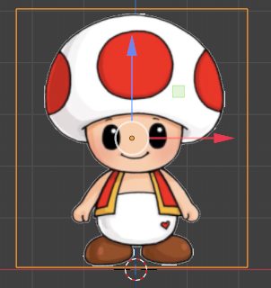

# Add a Plane

Hit 7 on the keypad to turn your view to the top view.

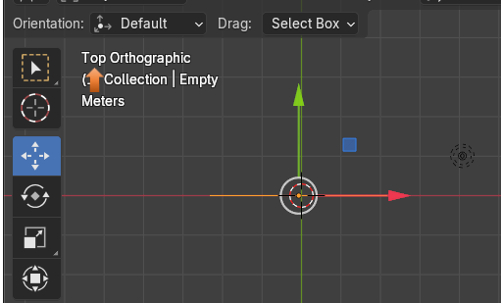

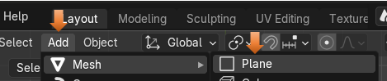

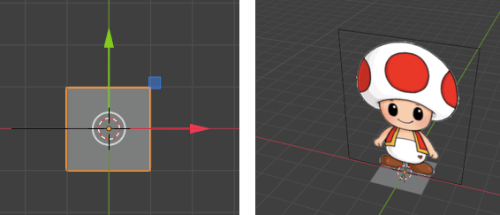

Select the Plane in the viewport

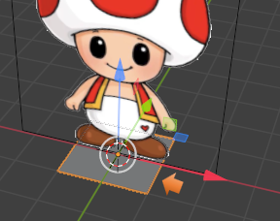

# Go into Edit Mode

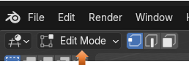

# Create a Single Vertex from the Plane

In Edit mode, we want to start out by selecting a single vertex on the plane, like this

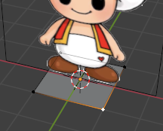

Now with that single vertex selected, we want to hit ctrl-I to reverse that selection. Because we actually want the other 3 vertexes selected, and not this one.

Ctrl-I

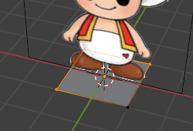

Now hit the X key to bring up the delete menu, and select Delete Vertices.

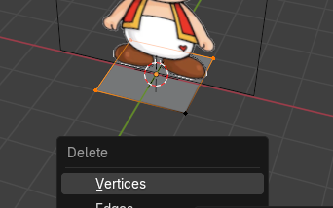

Now you will notice that you are left with this single vertex on the floor.

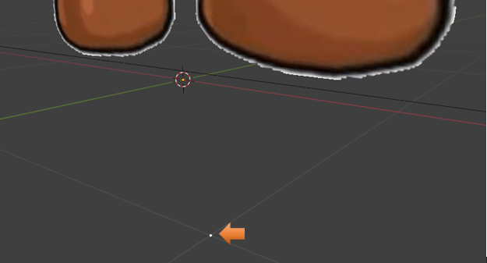

Select that vertex and then hit the G tool for grab, and grab it and move that vertex right here.

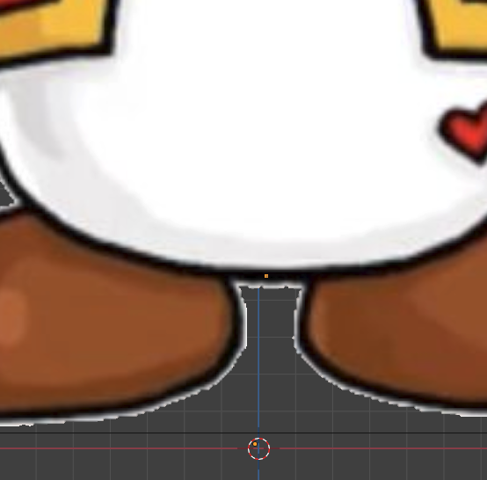

You might want to double check in side view to see if the vertex is actually on the reference image and not floating out into space somewhere.

Your reference image will only look like a single line when viewing from side view.

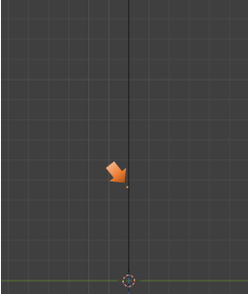

# Start drawing around the image with verticies

Go back to front view.

The way in which we can connect vertices is by hitting the hot key of E, which means extrude. So, we will be extruding each vertex and creating an out line of sorts.

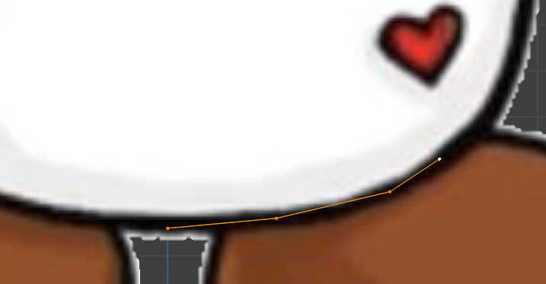

If you are only viewing one segment at a time. Try hitting the L key to select connected to view the entire line of vertices.

We want to stop at the top here. Take the mover tool and move that vertex slightly toward the left



After moving the vertex slightly to the left. Hit shift D to duplicate it and then move that dot downward to meet the chest.

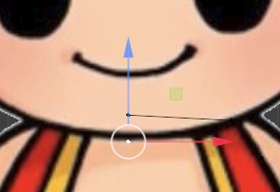

Now use that duplicated new dot to start drawing around the head.

Draw this one around like this. Notice that we are only drawing half of our subject, and notice that where we duplicated that first dot at the neck it is not connected to the body vertex in any way.

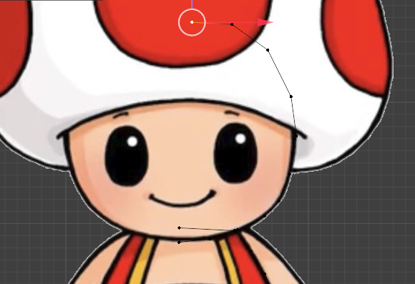

Ok, now we are at the top of our head with the vertex. We need to draw the hat. So, what we do is to duplicate that last vertex of our head Shift-D that last vertex to duplicate one for the hat. We want to move that duplicated vertex down to the bottom of the hat. Like this. Notice again that the head vertex and the hat vertex is not connected in any way. They are separate objects.

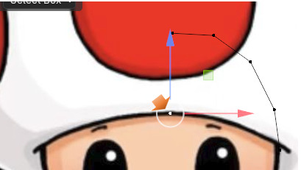

Start hitting the E key to extrude this dot around the hat.

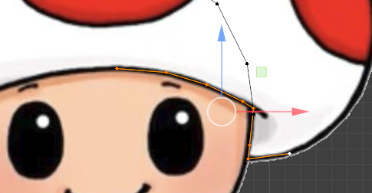

Your Reference Image is named an Empty in the Outliner, we can rename it to reference image and then hit the eye to temporarily hide it so we can see the lines that we created.

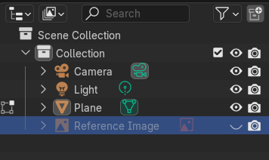

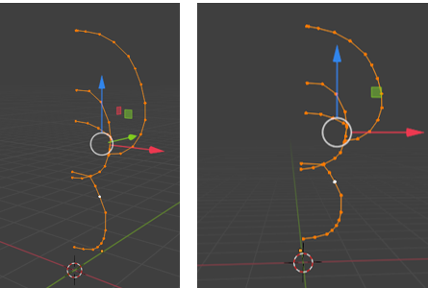

Before we can use the Modifier that we want to use, we need to adjust the position of the middle lines to be aligned.

On the numpad, hit 1 to go to front Orthographic view

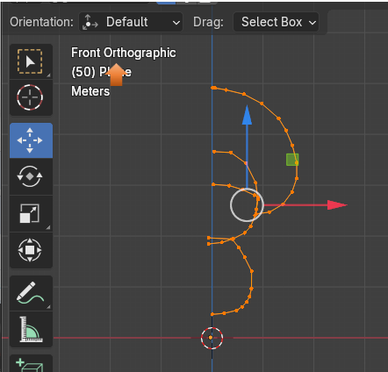

Now you want to box select all of the vertices on the left side of this thing. We need to put them all in one line. Make sure you only select the ones on the left edges. If the others seem too close you can use the G key and move the vertex along the line.

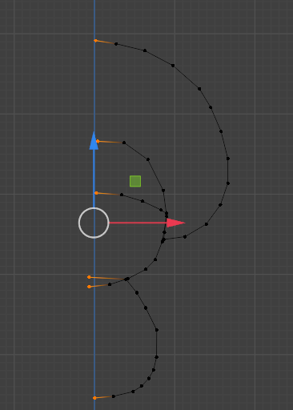

Now press S, X and then the number 0, to Scale them along X to be 0. It must be done in that order if you press X before S, it will want to deleted things, since X is the hot key for Delete. Now Things are Straight.

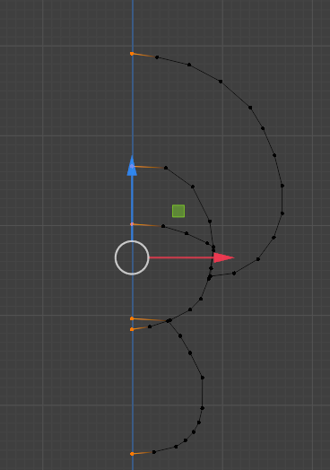

# Align the Cursor

Change the Cursor to be lined up with the bottom center Point on the Vertex Trace. We need to select just the bottom vertex on this spiral.

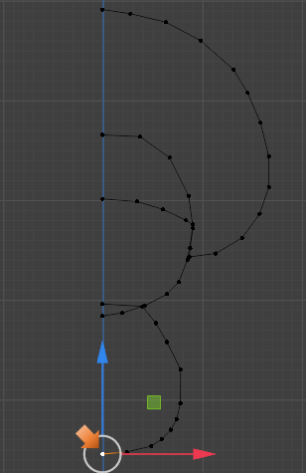

Now hit Shift S to bring up a menu Cursor To Selected

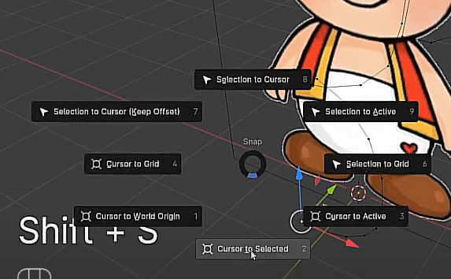

Now you will see that the cursor jumped to the vertex that we have selected.

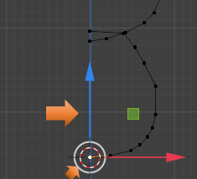

Now go back into Object mode

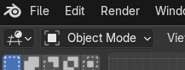

Notice in Object mode the wire is all together, we no longer see vertices that we had seen in Edit mode. But our Cursor is still glued to the bottom vertex that we had set up in Edit mode.

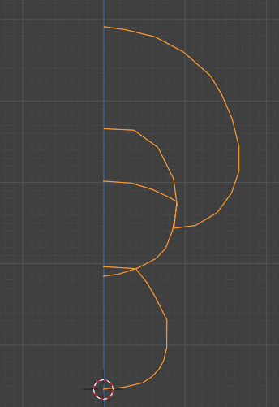

# Add Screw Modifier

Make sure you are in Object mode.

Go to the Modifier panel by selecting the wrench



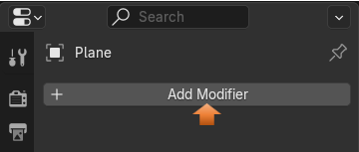

Search for the Screw Modifier

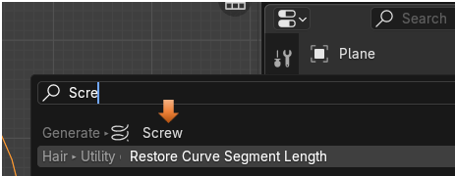

And as soon as we hit that modifier this shape magically appears. Trying to give us the shape that we were trying to trace.

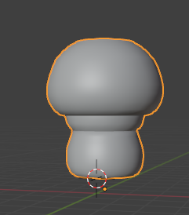

Turn on the eye to the reference image, and we can move this shape away from it now.

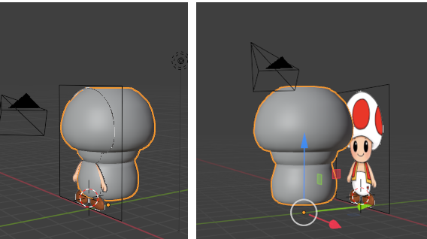

This is what shows up in the right- side panel for the Modifier. We can just apply it by going to this dropdown

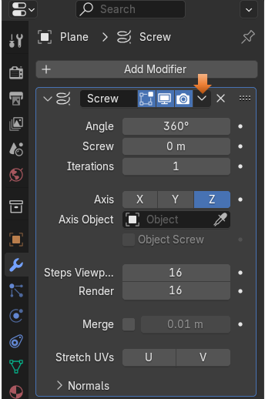

You will see once it is applied everything in the panel disappears for the modifier

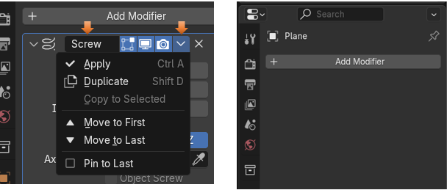

# Sub Division Surface Modifier

Now in the Modifier Panel add a Sub Division Modifier. You shouldn’t have to really search for it, it shows up at the top of the list.

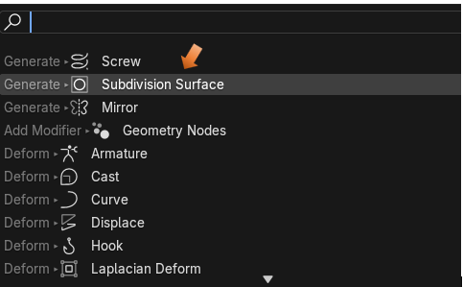

You can increase the Levels View to be 2, it is 1 by default

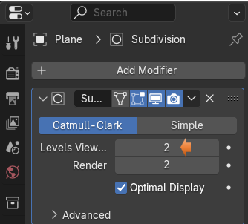

<https://www.youtube.com/watch?v=bwK7uk-A1y4>